STAT 520  Applied Multivariate Analysis | SIMULTANEOUS INFERENCE

Bonferroni confidence sets and confidence ellipsoid

Data SWEAT; /* # 5.7, p.261. Sweat data from Example 5.2. */
INFILE "C:\Users\baron\520\SAS and data\Johnson Wichern Data sets\T5-1.dat";
Input Rate Sodium Potassium; run;

PROC MEANS DATA=SWEAT N MEAN CLM ALPHA=0.0167; VAR Sodium;
/* CLM asks to compute (1-0.0167) confidence interval, where 0.0167=0.05/3 for p=3 */
OUTPUT OUT=Stats1 LCLM=LCL_Sodium UCLM=UCL_Sodium; run; /* Save confidence limits */

N | Mean | Lower 98.33%  CL for Mean | Upper 98.33%  CL for Mean
20 | 45.4000000 | 37.1060295 | 53.6939705

PROC MEANS DATA=SWEAT N MEAN CLM ALPHA=0.0167; VAR Potassium;
OUTPUT OUT=Stats2 LCLM=LCL_Potassium UCLM=UCL_Potassium; run;

DATA Stats; MERGE Stats1 Stats2; DO I=1 TO 20; OUTPUT; END; run; /* Duplicate rows */

DATA SWEAT; MERGE SWEAT Stats;
N=20; P=3; alpha=0.05;
CriticalF = (((N-1)*P)/(N-P))*FINV(1-alpha, P, N-P)/N;
LevelForChisq = 1-PROBCHI(CriticalF,P); run;

PROC PRINT DATA=SWEAT; run;

 |  |  |  |  |  | LCL_Sodium | UCL_Sodium | LCL_Potassium | UCL_Potassium |  |  |  |  | CriticalF | LevelForChisq
 |  |  |  |  |  | 37.1060 | 53.6940 | 8.84739 | 11.0826 |  |  |  |  | 0.53593 | 0.91093

PROC SGPLOT DATA=SWEAT;  scatter X=Sodium Y=Potassium;  scatter X=Sodium Y=LCL_Potassium;  scatter X=Sodium Y=UCL_Potassium;  scatter X=LCL_Sodium Y=Potassium;  scatter X=UCL_Sodium Y=Potassium;  ellipse X=Sodium Y=Potassium / alpha=0.91093;  run; | 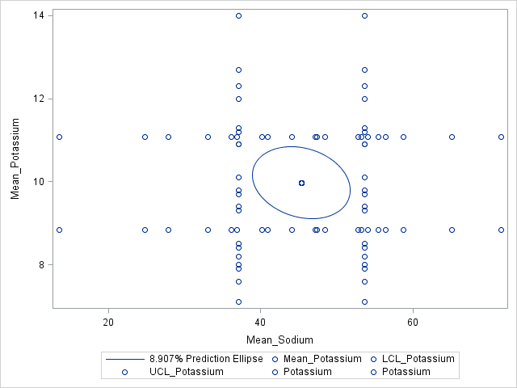

Simultaneous hypothesis testing. Adjustments for multiplicity.

Data SWEAT; set SWEAT;
Y1=RATE-4; Y2=SODIUM-50; Y3=POTASSIUM-10; run; /* Now we just test Ho: MU = 0 */

PROC MEANS DATA=SWEAT PROBT; VAR Y1; OUTPUT OUT=SWEAT_PVAL1 PROBT=raw_p; run;
/* Save p-values from standard two-sided t-tests */
PROC MEANS DATA=SWEAT PROBT; VAR Y2; OUTPUT OUT=SWEAT_PVAL2 PROBT=raw_p; run;
PROC MEANS DATA=SWEAT PROBT; VAR Y3; OUTPUT OUT=SWEAT_PVAL3 PROBT=raw_p; run;
DATA SWEAT_PVAL; SET SWEAT_PVAL1 SWEAT_PVAL2 SWEAT_PVAL3; run;

PROC MULTTEST PDATA=SWEAT_PVAL BON HOLM HOMMEL SIDAK; RUN;
p-Values
Test | Raw | Bonferroni | Stepdown Bonferroni | Sidak | Hommel
1 | 0.1080 | 0.3240 | 0.3240 | 0.2903 | 0.2428
2 | 0.1619 | 0.4856 | 0.3240 | 0.4113 | 0.3238
3 | 0.9354 | 1.0000 | 0.9354 | 0.9997 | 0.9354

Compare margins of simultaneous confidence intervals

DATA MARGINS; alpha=0.05; N=1000;
DO p=1 to 100 by 4;
Bonf_Margin = TINV(1-alpha/p,n-1);
T2_Margin = sqrt( p*(n-1)/(n-p)*FINV(1-alpha,p,n-p) );
Chisq_Margin= sqrt( CINV(1-alpha,p) );
OUTPUT; /* This is needed to save results for each p */
END;

PROC GPLOT DATA=MARGINS;
PLOT Bonf_Margin*p='B' T2_Margin*p='F' Chisq_Margin*p='C' / OVERLAY; run;
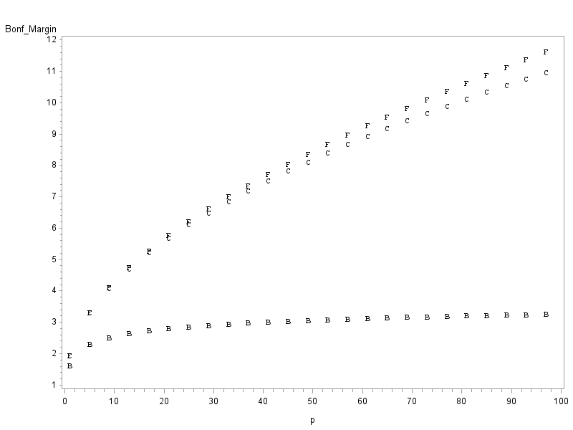
Fun fact: more sodium, less potassium when sweating faster
PROC SGPLOT DATA=SWEAT;  scatter X=Rate Y=Sodium;  scatter X=Rate Y=Potassium;  ellipse X=Rate Y=Sodium;  ellipse X=Rate Y=Potassium;  run; | 